我也曾有过这种做法。现在想起来：后怕！

我以前经常这麼做 今后，再也不会了！
I do this all the time … I guess I won’t be doing it ANY more !
手机在充电？？？
Cell phone was plugged in???
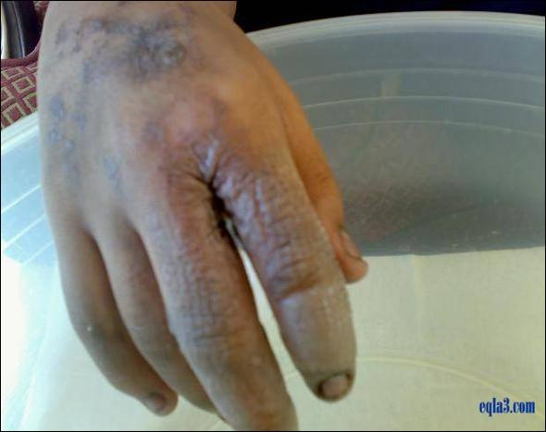
几天之前，一人在家中给手机充电。
A few days ago, a person was recharging his mobile phone at home.
就在此时，电话铃响，他没有拔下充电器便直接接听。
Just at that time a call came in and he answered it with the
Instrument still connected to the outlet.
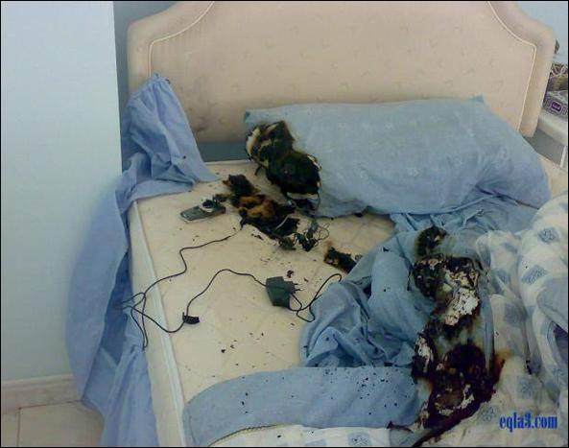
几秒之后，强大电源流过手机，年轻人被击倒在地。
After a few seconds electricity flowed into the cell phone unrestrained
and the young man was thrown to the ground with a heavy thud.
他的父母沖进房间，发现他已失去了意识，心跳微弱，手指烧焦。
His parents rushed to the room only to find him unconscious, with
a weak heartbeat and burnt fingers.

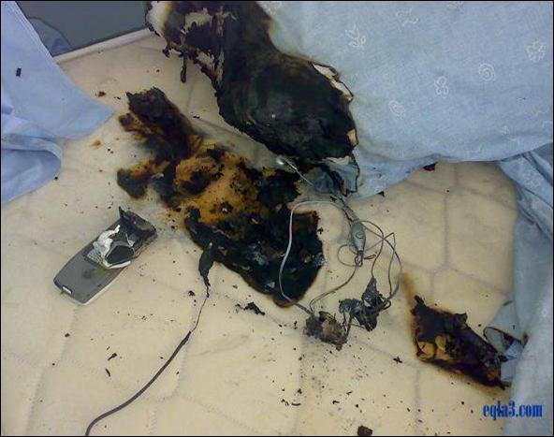
他被立即送往医院，但是到达时即被宣佈死亡。
He was rushed to the nearby hospital, but was pronounced dead on arrival.
手机是非常实用的现代发明。
Cell phones are a very use fu l modern invention.

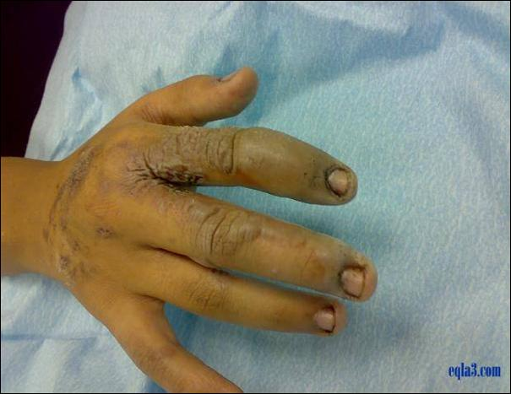
然而，我们必须警惕，手机也可能是致命武器。
However, we must be aware that it can also be an instrument of death.
再也不要在连接电源时使用手机！
Never use the cell phone while it is hooked to the electrical outlet!
请把此封邮件转发给您关爱的人！！！
FORWARD THIS TO THE PEOPLE THAT MATTER IN YOUR LIFE!!!!

